Chapter 4: Resources

4.1 Resources on Earth are either renewable or non-renewable

Student worksheet answers (pages 62–63)

Renewable and non-renewable resources

1 Examine the images of different environmental resources. Write what type of resource it is and a brief overview of the resource.

|  |  |  |
| --- | --- | --- |
| **Resource image** | **Type of resource** | **Overview of the resource** |
| L:\1. Publishing and Editorial\1. Product\Oxford Science\Oxford Science 7\3. Extras\4. Answers\Artwork\4. Final jpgs\WS0409_00883.jpg | Continuous | Ocean waves can be used to generate electricity |
| L:\1. Publishing and Editorial\1. Product\Oxford Science\Oxford Science 7\3. Extras\4. Answers\Artwork\4. Final jpgs\WS0410_00883.jpg | Renewable | Plants are regrown by the seeds they produce |
| L:\1. Publishing and Editorial\1. Product\Oxford Science\Oxford Science 7\3. Extras\4. Answers\Artwork\4. Final jpgs\WS0411_00883.jpg | Continuous | Wind is used to turn turbines to generate electricity |
| L:\1. Publishing and Editorial\1. Product\Oxford Science\Oxford Science 7\3. Extras\4. Answers\Artwork\4. Final jpgs\WS0412_00883.jpg | Non-renewable | Electricity is generated from the burning of coal |
| L:\1. Publishing and Editorial\1. Product\Oxford Science\Oxford Science 7\3. Extras\4. Answers\Artwork\4. Final jpgs\WS0413_00883.jpg | Renewable | Forests can be replanted after logging occurs |
| L:\1. Publishing and Editorial\1. Product\Oxford Science\Oxford Science 7\3. Extras\4. Answers\Artwork\4. Final jpgs\WS0414_00883.jpg | Non-renewable | Oil is extracted and is one of the worlds most commonly used energy sources |

2 Environmental resources can be classified as renewable and non-renewable. Classify the following items by thinking about which environmental resource they originally came from (e.g. paper products came from forests, therefore are renewable resources).

a Petrol for your family car:

Non-renewable

b A cardboard box:

Renewable

c The wind that turns a turbine:

Continuous

d Soil that is in your garden:

Renewable

e The coal that provides electricity:

Non-renewable

f Water that you drank yesterday:

Continuous

g The fertiliser that was used on a farm:

Non-renewable

h Gold that is in a necklace or earring:

Non-renewable

i Geothermal energy from the Earth:

Continuous

j A plastic wrap you had your lunch in:

Non-renewable

3 How is the Sun’s energy linked to:

a water as a renewable resource?

The Sun’s energy provides the power required for the water cycle to occur.

b plants as a renewable resource?

The Sun’s energy provides the energy required for photosynthesis to occur.

EXTEND YOUR UNDERSTANDING

4 Even though forests are renewable resources, if the trees that are logged are not replaced, either naturally or by humans, the forest resource may become non-renewable in some places.

a What are the top five countries with the most amount of forest.

The top five countries with the most amount of forest are Russia, Brazil, Canada, USA and China.

b What are the top five countries with the most amount of cleared forest.

The top five countries with the most amount of cleared forest are Russia, Brazil, Canada, USA and China. (Australia is ranked sixth.)

c Is there a relationship between these two statistics?

Yes: those countries with the most amount of forest have also cleared the most amount of forest.

4.2 Renewable resources can be quickly replaced

Student worksheet answers (pages 64–65)

Replaceable resources

1 The pie chart shows the use of Australia’s energy resources.

a Rank the energy resources from highest percentage use to the lowest.

Coal, gas, hydro, wind, crude oil, solar, geothermal

b List the energy resources that are from renewable energy sources.

Solar, wind, geothermal and hydro are renewable energy sources.

c What is the total percentage of Australia’s energy that comes from renewable resources?

6.2% of Australia’s energy comes from renewable resources.

d Australia is one of the highest greenhouse gas emitters in the world. How do you think Australia’s mining exports contribute to greenhouse gas emissions in other countries of the world?

Australia exports coal to other countries around the world. These countries would burn the coal to generate electricity, which would contribute to greenhouse gas emissions.

2 Using the map of Australia on page 65of the textbook, answer the following questions:

a Where in southern parts of Australia are most of the wind power stations found?

Most wind power stations are found on the coast or just offshore in Victoria, South Australia and Tasmania.

b Why do you think the wind power stations are found on the coast or offshore in the southern parts of Australia?

Student responses will vary, but factors such as wind speed and proximity to major cities could be considered.

c Where in Australia are most of the coal energy resources found?

Most coal energy reserves are found in eastern Australia, especially in a line through Queensland and into New South Wales, with another place in Victoria.

d Natural gas resources are found in many different parts of Australia. Name one place where natural gas resources are located in the following states and territories:

i Northern Territory:

Mereenie and Palm Valley

ii Western Australia:

North West Shelf and Ichthys

iii Queensland:

Jackson and Tintaburra

iv Victoria:

Tuna, Flounder and Kingfish

v South Australia:

Tirrawarra

EXTEND YOUR UNDERSTANDING

3 Research why there is a cluster of hydro power stations near the Snowy Mountains around the border of Victoria and New South Wales. Present your findings as a combination of images and text on a single piece of paper.

a When and why were these hydro power stations built?

b How big is the hydro power stations project?

c How do the hydro power stations create energy?

d Were there any problems or difficulties during the construction of the hydro power stations?

Student responses will vary, although the following website is a very good source of information: <http://www.snowyhydro.com.au/energy/hydro/snowy-mountains-scheme/>

4.3 Renewable resources can be harnessed to provide energy

Student worksheet answers (pages 66–67)

Renewable energy

1 Renewable energy sources have both advantages and disadvantages for the environment. The advantages tend to be on a global scale, but the disadvantages are often in the local area. Fill in the table below to explore this further.

|  |  |  |
| --- | --- | --- |
| Renewable resource | Advantages | Disadvantages |
| Wind energy | • No emissions  • Little environmental impact | • Wind needs to be blowing  • Visually unappealing |
| Solar energy | • No emissions  • Natural source of energy | • Relies on the Sun being present  • Expensive infrastructure |
| Geothermal energy | • Constant energy source  • Cheap source of energy | • Expensive infrastructure  • Long-term impact unknown |
| Hydroelectric energy | • Renewable energy source  • Stores water for other uses | • Requires large dams and flooding of valleys |
| Tidal energy | • Offshore, so little visual impact  • Constant source of energy | • Expensive infrastructure  • Impact on the local ecosystem |

2 The various renewable energy resources provide power that can be used as an alternative to burning fossil fuels, but have you experienced this energy? Describe how you can or have experienced the power from renewable energy resources; for example, you may describe visiting the hot springs in New Zealand as an example of how you experienced geothermal energy.

a The power of the wind

Student responses will vary but could include standing outside on a very windy day.

b The power of the Sun

Student responses will vary but could include getting sunburnt or suffering heat stroke during summer.

c The power of the waves or tides

Student responses will vary but could include getting knocked over by a wave at the beach.

d The power of flowing water

Student responses will vary but could include standing in a strongly flowing river.

e The power of the Earth’s heat

Student responses will vary but could include seeing a volcano or geyser.

EXTEND YOUR UNDERSTANDING

3 There are other renewable energy resources that are being used and developed to provide sustainable and environmentally friendly power for different places around the world. Discover a little more about the following renewable energy resources:

• Biomass

Biomass is a fuel developed from organic materials. It is a renewable and sustainable source of energy used to create electricity or other forms of power

• Biofuel

Biofuel is produced through contemporary biological processes, such as agriculture and anaerobic digestion

• Biological hydrogen production

Hydrogen produced by algae can be used as a fuel

4.4 Non-renewable resources are limited

Student worksheet answers (pages 68–69)

Fossil fuels

1 Review your understanding of the formation of coal by describing what happens at each stage:

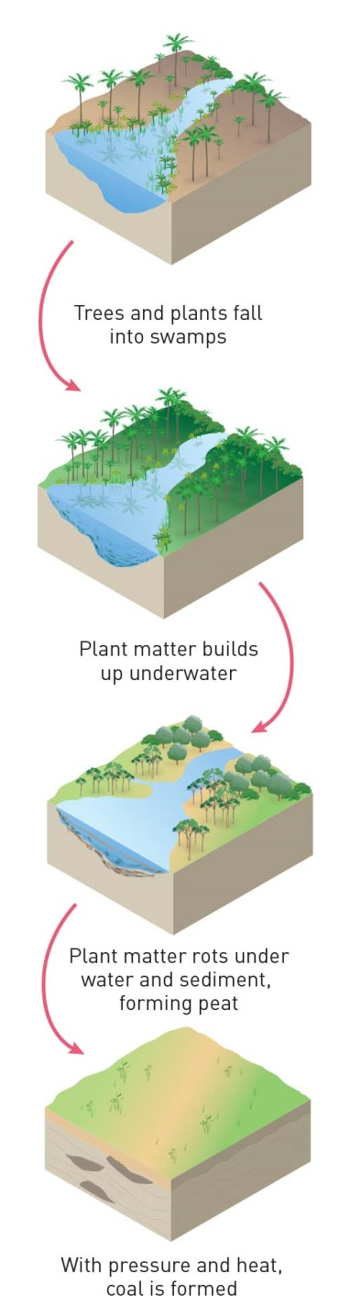

2 Draw a simple flow chart to explain how uranium is used to produce electricity.

Uranium is mined from the ground → the energy from splitting uranium heats water → the water turns into steam → the steam drives turbines → the turbines drive generators that produce electricity

3 Coal-fired power stations burn coal to produce electricity. When coal is burned, heat is used to boil water to make steam. The steam is used to make a turbine spin. The turbine is connected to a generator, which converts the movement from the turbine into electrical energy. How is this similar to the way electricity is produced by uranium?

The similarity between coal-fired power stations and uranium is that both use the energy released to heat water, which is turned into steam to turn turbines that drive generators that produce electricity.

EXTEND YOUR UNDERSTANDING

4 The mining of ore deposits can result in the extraction of small quantities of minerals from huge quantities of ores. Before you mine your muffin in the ‘What if a muffin were mined in different ways?’ experiment, include the following processes in your method. You will need a set of electronic scales.

a What is the weight the muffins before you start mining?

Student responses will vary.

b What is the weight of the chocolate you extracted?

Student responses will vary.

c Research whether this is similar to a typical yield of aluminium from bauxite mined at Weipa.

The typical yield of aluminium from bauxite mined at Weipa is about 50%.

4.5 Soil is one of our most valuable resources

Student worksheet answers (pages 70–71)

Soil as a resource

1 What do you think is the difference between soil and dirt?

Student responses will vary, but soil is a complex mixture of materials, such as sand, silt clay, humus and minerals. Dirt is often described as the substance that is on your hands or clothes after touching soil.

2 The diagram below is a soil profile, which shows the different layers in the top section of the soil.

a Use the following words to label the different layers of the soil profile:

• Small and larger rocks

• Grass and leaf litter

• Hard rock layer

• Humus

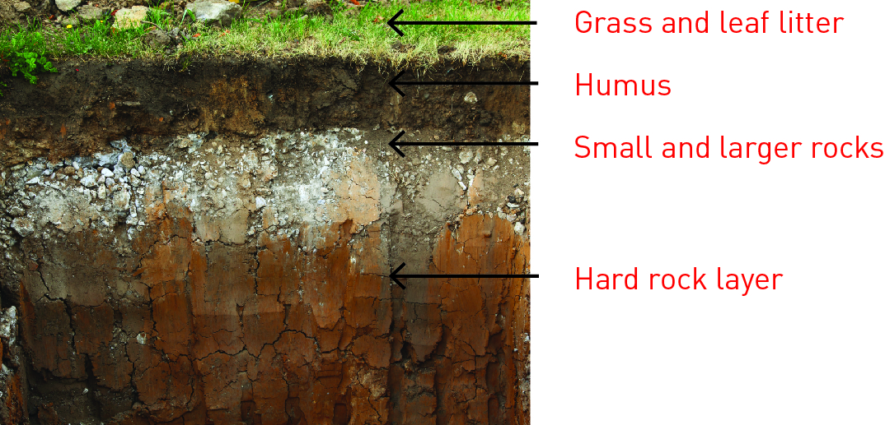

b Which layer of the soil would contain decomposed plants and animals?

Humus would contain decomposed plants and animals.

3 What could you add to poor soil to make it healthy in the following examples?

a The soil is draining very quickly and drying out.

Clay, humus or wetting agents could be added to the soil.

b The soil is lacking organic content.

Humus or organic fertilisers, such as manure and compost, could be added to the soil.

c The soil is unhealthy because of a lack of organisms.

Organisms such as worms could be added to the soil.

d The soil structure lacks nutrients.

Fertilisers or other chemicals could be added to change the soil structure.

e The soil is becoming waterlogged and muddy.

Sand could be added to allow the soil to drain.

4 The farmland in the image below is suffering from severe erosion and the topsoil is very poor quality. What can the farmer do to improve this land?

The farmer could take a number of actions, including: planting vegetation so that the roots reduce erosion and the water table level; adding manure and other organic matter to improve the soil; adding organisms, such as worms, to keep the soil healthy; and consulting Indigenous Australians for advice on managing the land.

EXTEND YOUR UNDERSTANDING

5 Examine the soil at or near your home. Complete ‘B What’s in soil?’ from Experiment 4.5 by using a soil sample and a jar from home. Compare this sample with the ‘good garden soil’ sample from the experiment and describe any similarities or differences.

Student responses will vary depending on the soil gathered and the results of their experiment.

4.6 Our future depends on careful management of resources

Student worksheet answers (pages 72–73)

Resource management

1 Complete the following sentences to revise the future of resources.

a LEVs are low emissions vehicles.

b Hybrids use a mix of petrol and electricity.

c Ethanol is an abbreviation of ethyl alcohol.

d BlueGen fuel cells burn natural gas in an efficient closed system.

e Smart plugs will monitor the electricity used by each appliance.

2 In the home of the future there will be many different ways to make sure it is resource and energy efficient. What could the ‘smart home’ do in each of these situations?

a You left your bedroom light and when you left for school.

The smart home would switch off the light when the Sun comes out.

b You also left the television on.

The smart home would send you an alert so you could turn off the television remotely.

c You flush the toilet.

The smart home uses gravity-fed rainwater tanks under the eaves to flush the toilet.

d The winter sun has warmed the house surfaces, but inside gets cold at night.

The smart home releases stored heat at night.

e You can charge your phone and laptop from electricity made by your home.

The smart home generates solar electricity.

EXTEND YOUR UNDERSTANDING

3 The LEV and hybrid cars reduce the use of fossil fuels and the emissions that contribute to greenhouse gases, but do they have any other environmental impacts? Using the Internet, research the environmental impacts that the construction of environmentally friendly cars potentially have. You may want to consider mining the materials, transporting parts, electricity needed to charge batteries, the land used for biofuels etc.

Student responses will vary, but the following website may assist with the research: <http://science.howstuffworks.com/science-vs-myth/everyday-myths/does-hybrid-car-production-waste-offset-hybrid-benefits.htm>

4.7 Science as a human endeavour: Green jobs will increase in the future

Student worksheet answers (pages 74–75)

Green jobs

The images below show different people working in green jobs.

Choose one of the green jobs: think about what the job may be and imagine that you are the person performing that job. Use the green job profiles as a guide, apply your understanding of resources that you have gained during this chapter and undertake further research online to complete the following questions.

1 My typical day at work:

Student responses will vary depending on the ‘green job’ they have chosen and their interpretation of the image.

2 Why I love my job:

Student responses will vary depending on the ‘green job’ they have chosen, but factors such as research, helping the environment, places the job takes you etc. could be considered.

3 Worst thing about my job:

Student responses will vary depending on the ‘green job’ they have chosen, but factors such as the places the job takes you, the potential hazards and possibly the pay could be considered.

4 Skills, courses or training I needed for my job:

Student responses will vary depending on the ‘green job’ they have chosen.

5 The ways my job helps the environment in the future:

Student responses will vary depending on the ‘green job’ they have chosen, but factors linked to the environment, sustainability, renewable energy, climate change etc. could be considered.

EXTEND YOUR UNDERSTANDING

6 Each year, Newsweek magazine publishes its list of the top 10 green companies in the world. In 2015, an American company by the name of Biogen took first place in the rankings. Conduct research on the Internet and answer the following questions.

a What kind of company is Biogen? What does it produce?

Biogen is a large biotechnology and pharmaceutical company that produces medicines to treat people with neurological diseases (i.e. those affecting the nervous system), autoimmune diseases (i.e. those affecting the immune system), and other rare diseases.

b List three areas Biogen has invested in to become carbon neutral.

1 Carbon emissions – reducing the amount of carbon emitted during the production of products

2 Water use – using less water and recycling more.

3 Waste – reducing the amount of waste produced and making sure it doesn’t go into landfill.

c In what year did Biogen become carbon neutral for the first time. What does this actually mean?

Biogen became carbon neutral in 2014. To become carbon neutral they reduced their emissions and then invested in programs (like planting trees) that ‘offset’ the remaining carbon that they did emit, making their emissions equal to zero.

d Watch the video on the Biogen website (under ‘Environmental sustainability’). The Vice President of the company talks about the importance of being a ‘good corporate citizen’. What does he mean by this?

According to the Vice President, being a ‘good corporate citizen’ means that the company must care deeply about the people they serve (i.e. their customers), the people who work there (i.e. their employees), and also the world in which they do business. All of the things the company does must make business sense, but also be environmentally responsible.